Transit GW, S3 , IAM role

1-Creating VPC

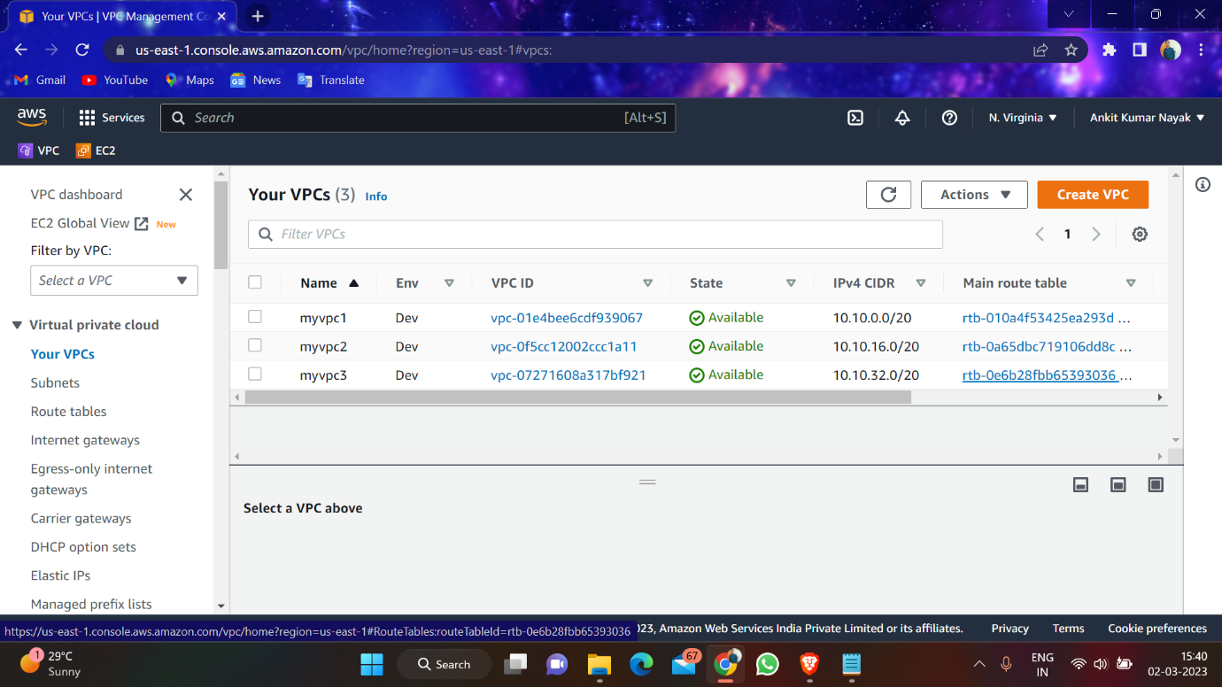

2-Creating Subnet

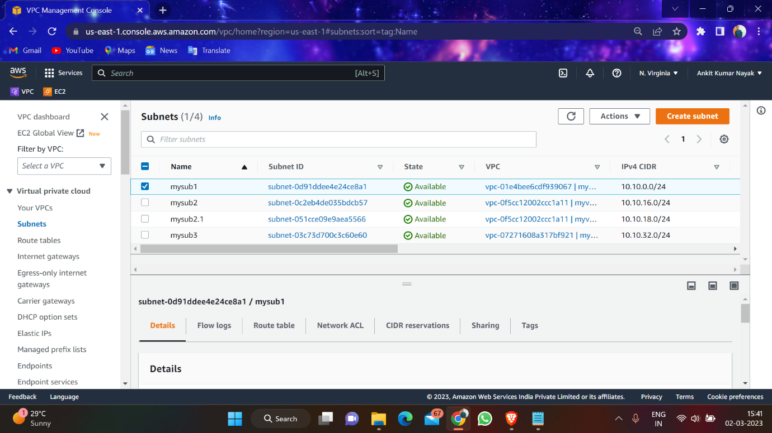

3-Creating route tables

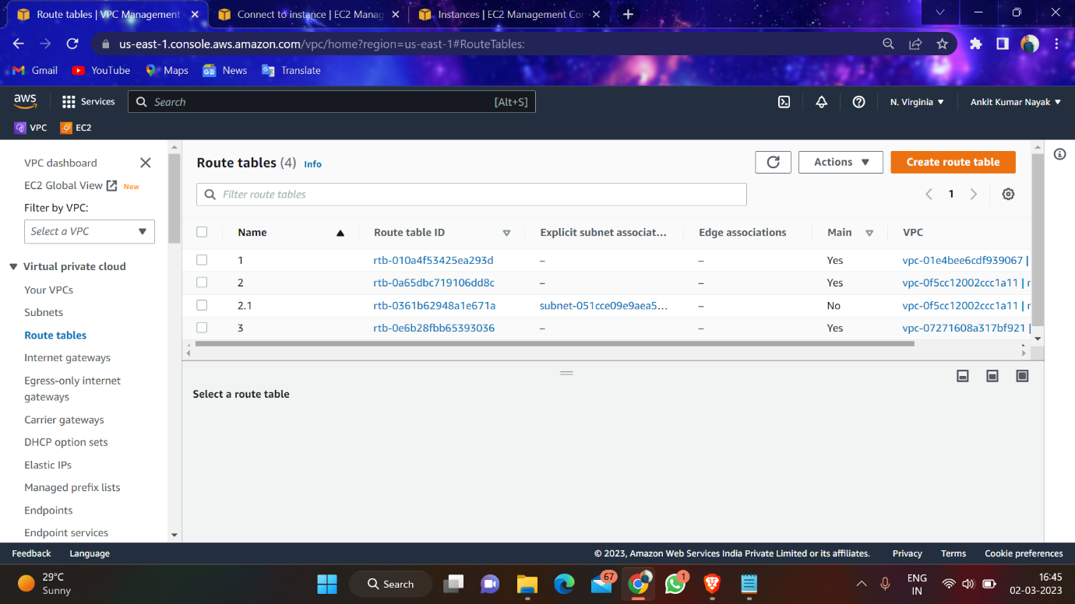

4-Creating Internet gateway and attach to vpc

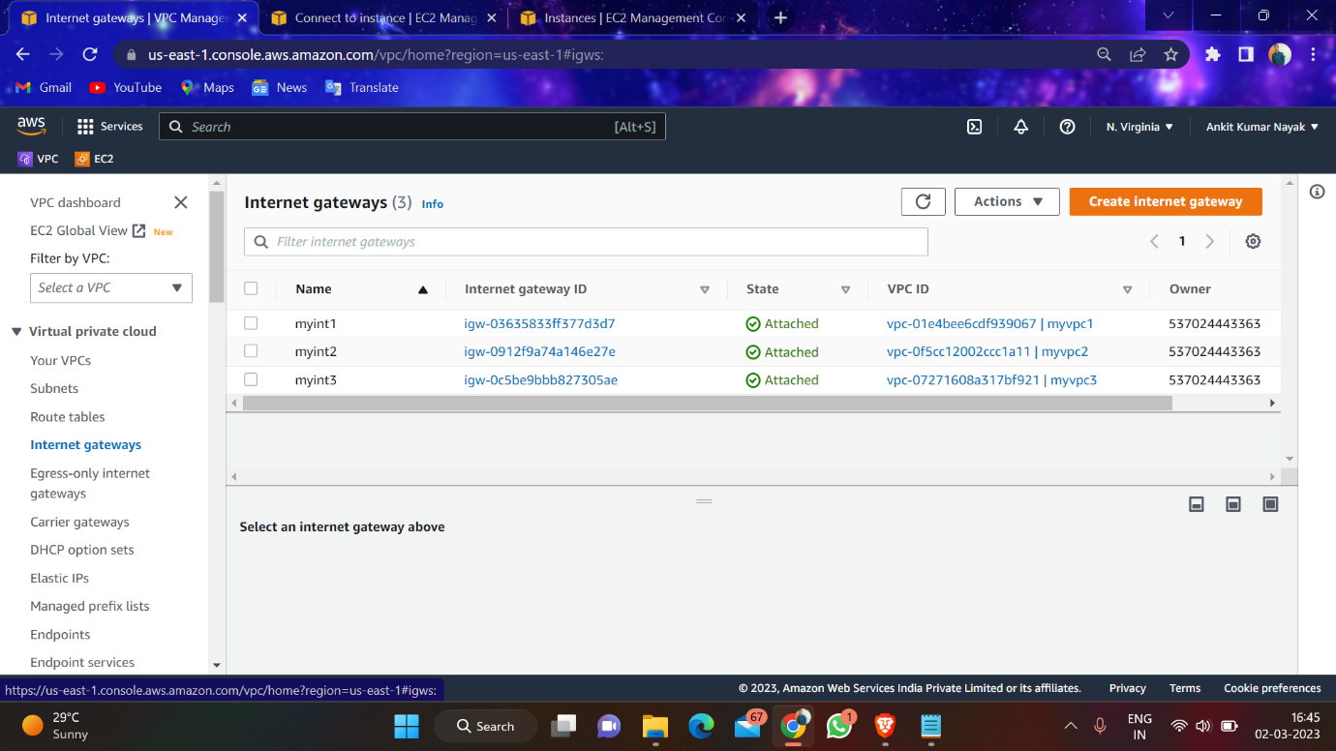

5-Creating transit gateways

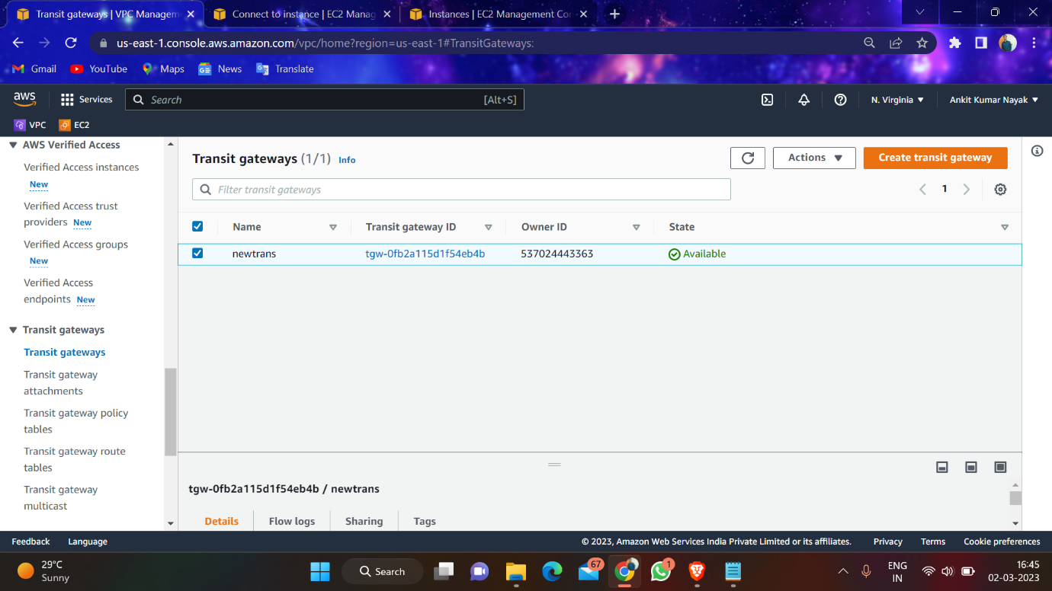

6-Creating transit gateway attachment

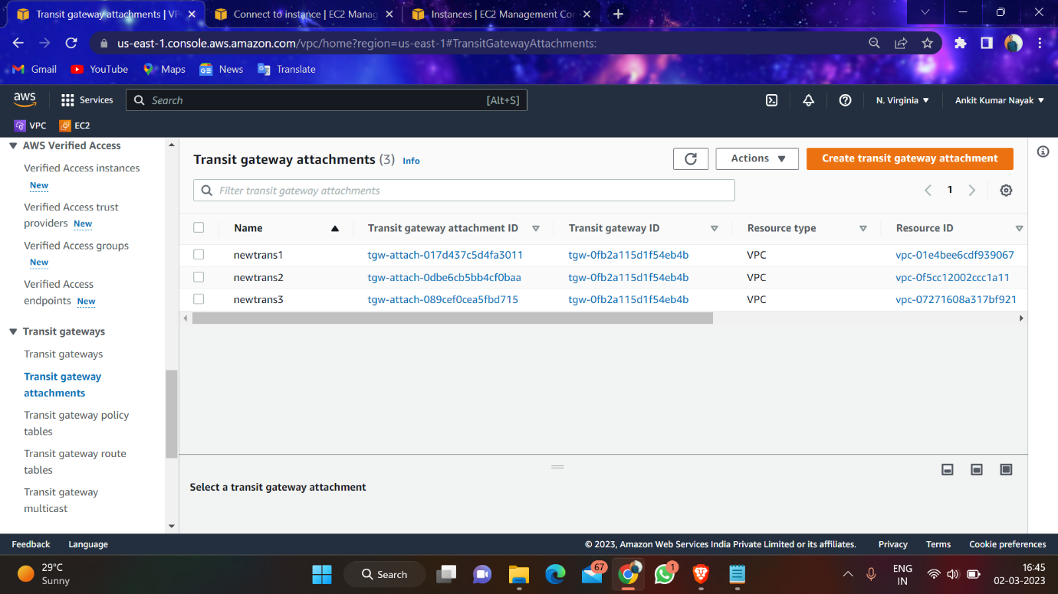

7-Creating Instance

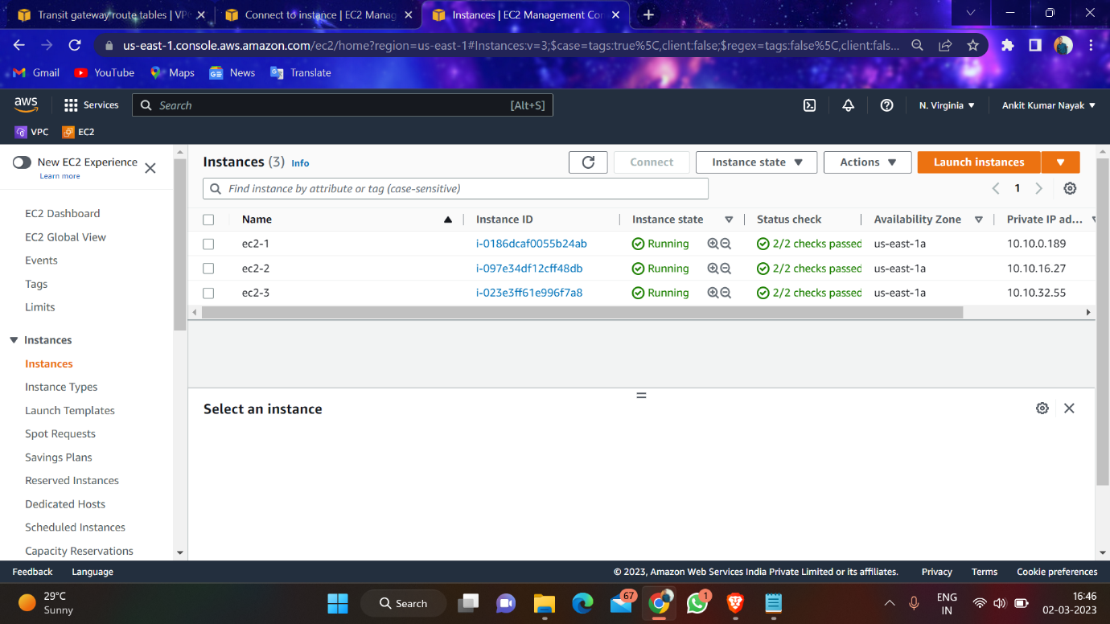

8- Machine 1 should ping with machine 2, and machine 1 should ping with machine 3

Machine 1—Machine 2

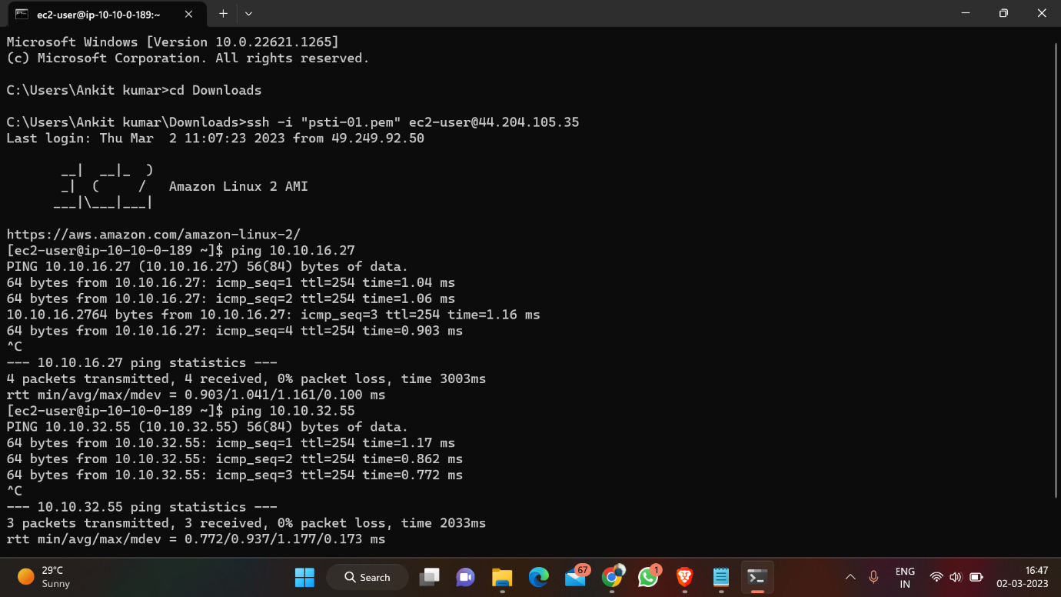

Machine 1—Machine 3

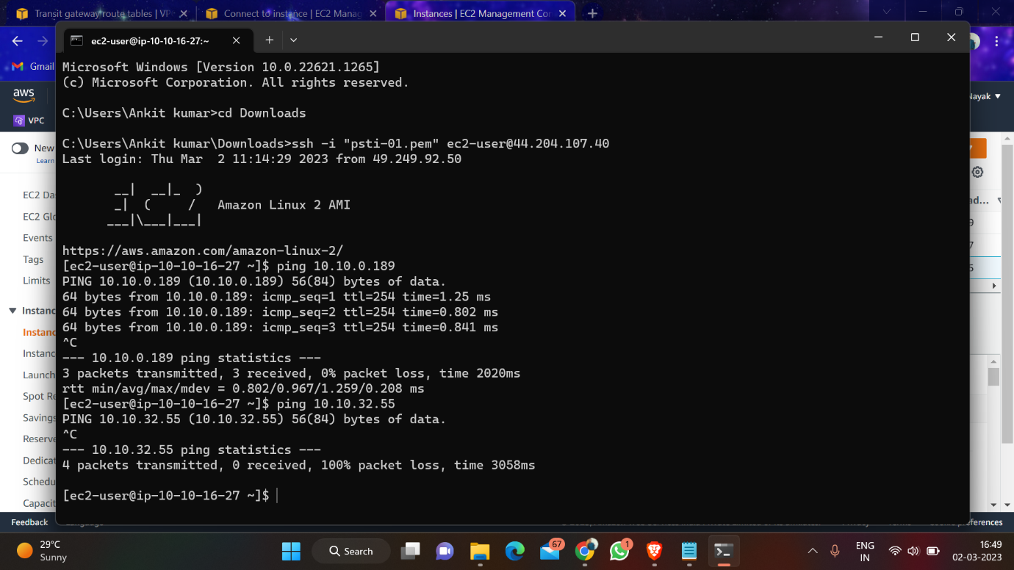

Machine 2—Machine 3 nothing pinging

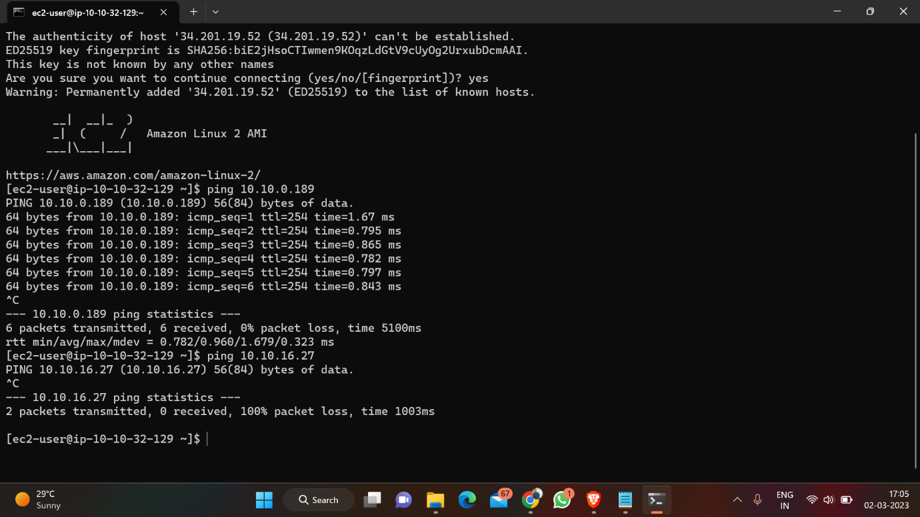

9- Create Buckets in same region

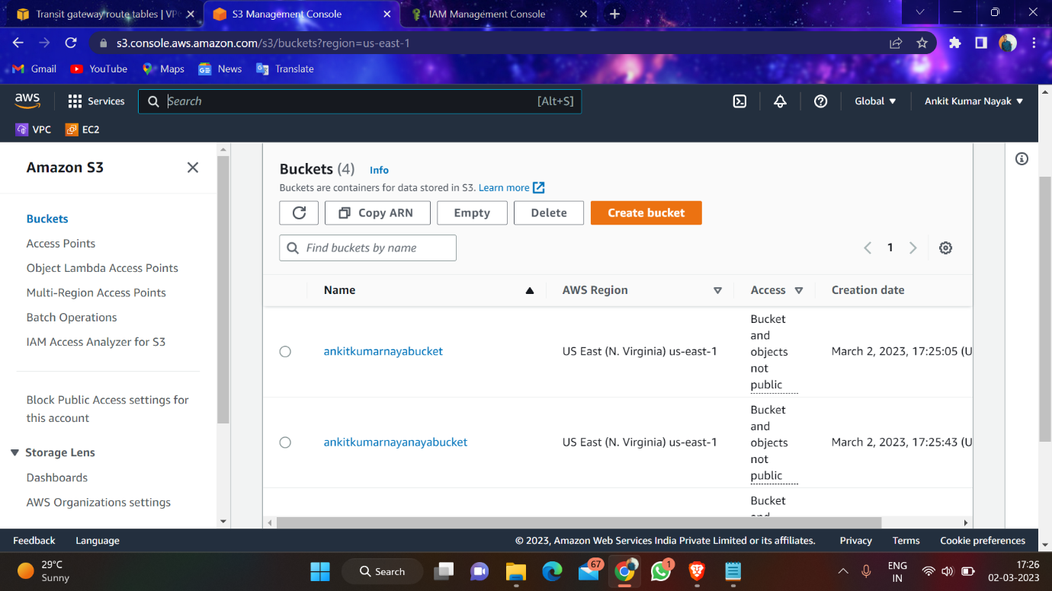

10- Create 2 poloies with 2 buckets

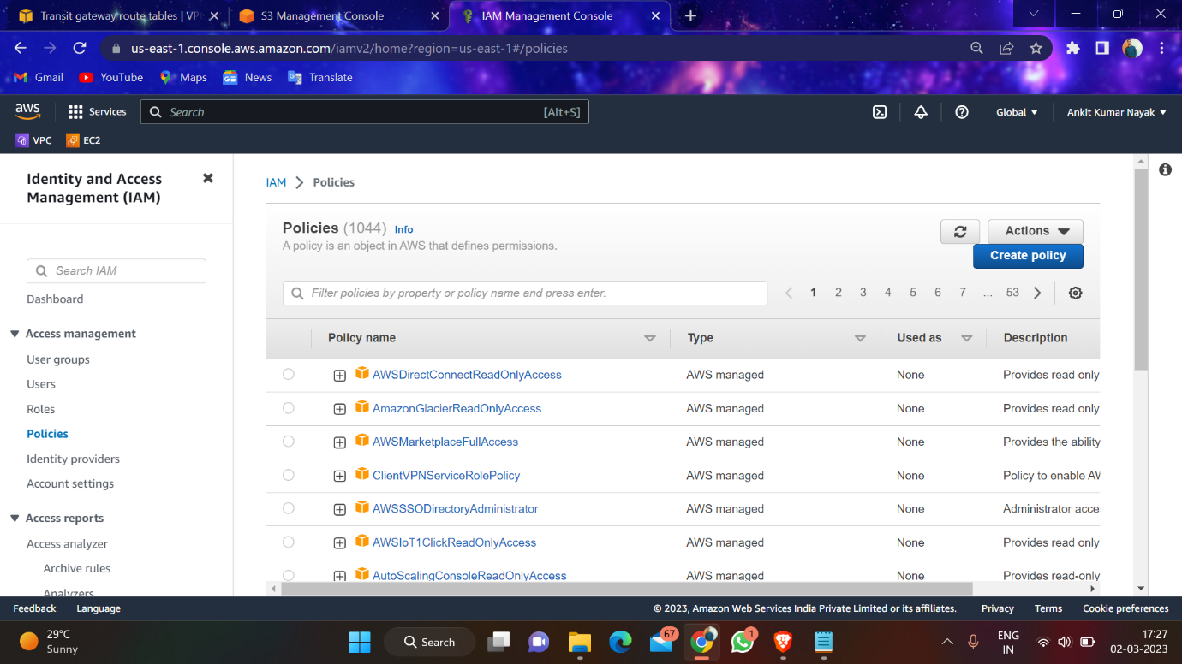

\*read only poloies

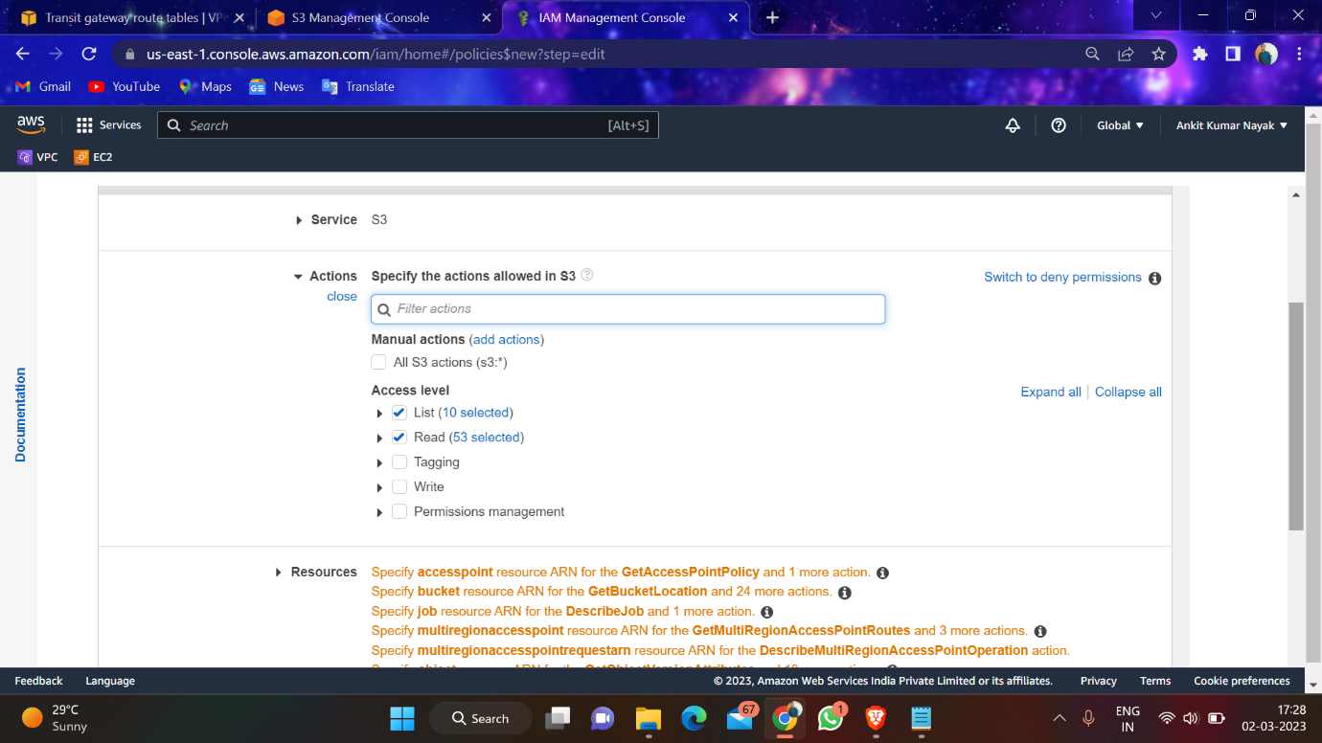

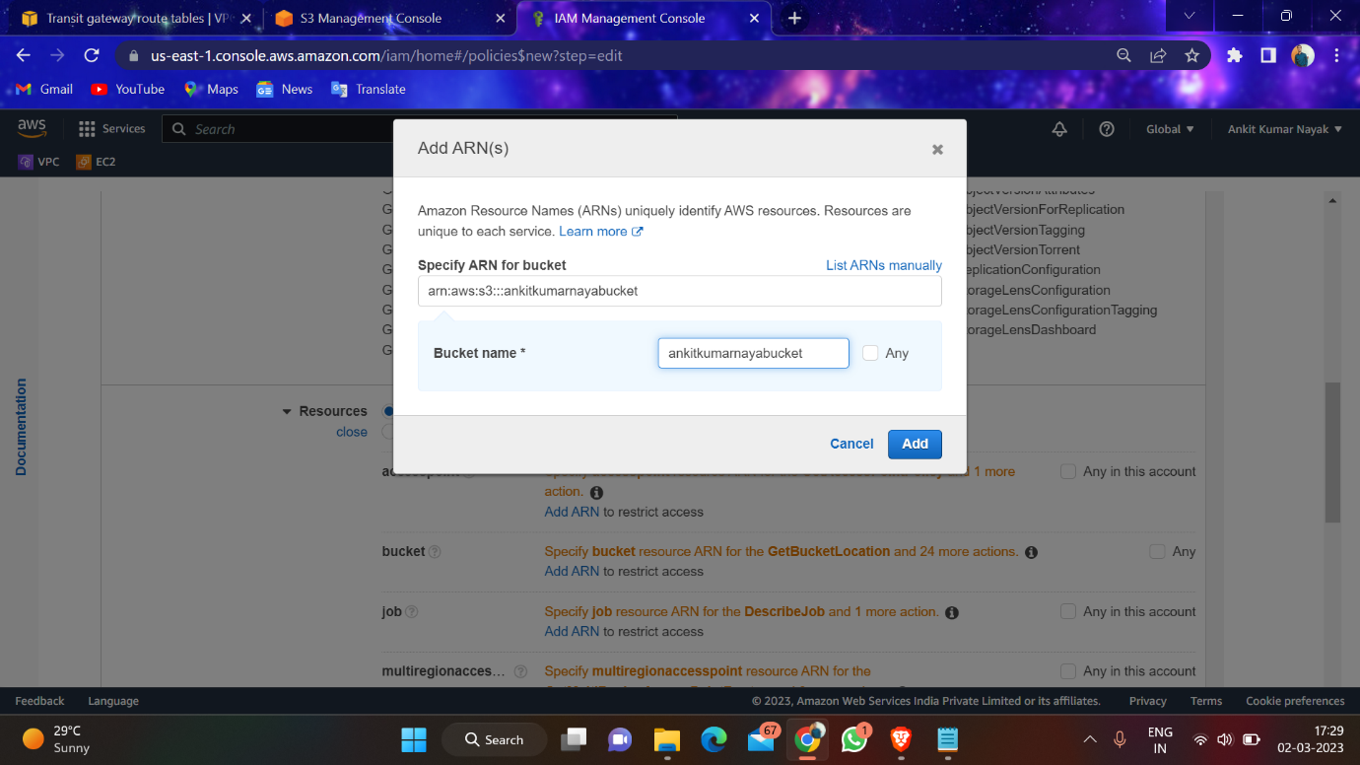

\*read and write poloies

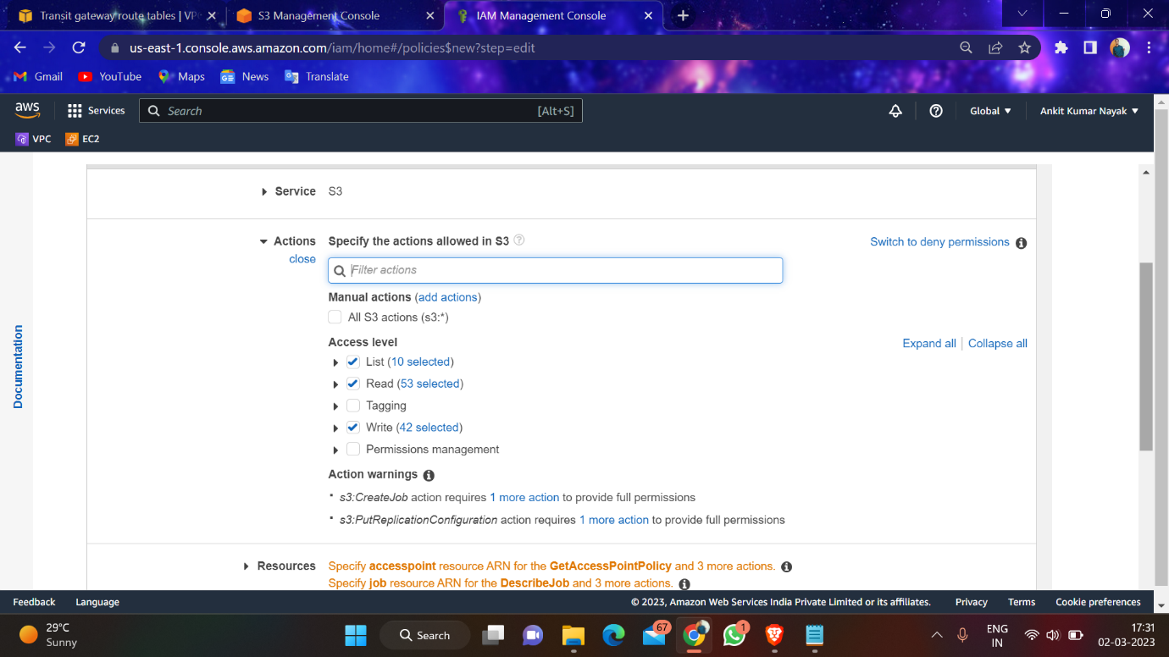

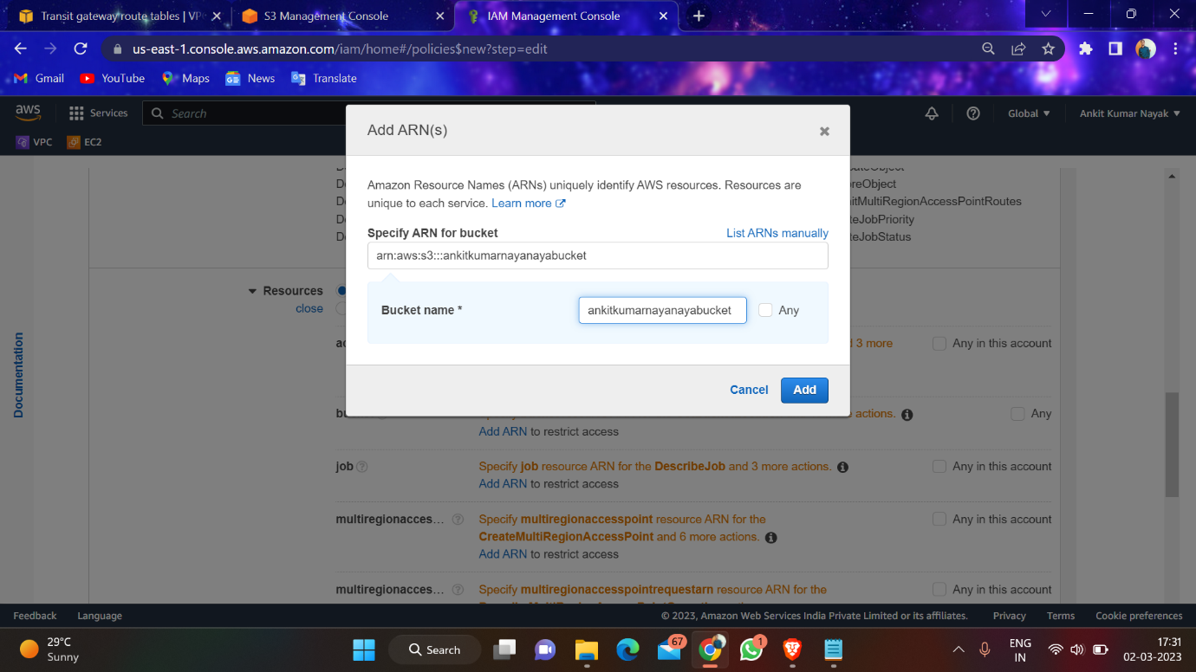

11- Create 2 roles in IAM

For 1st bucket

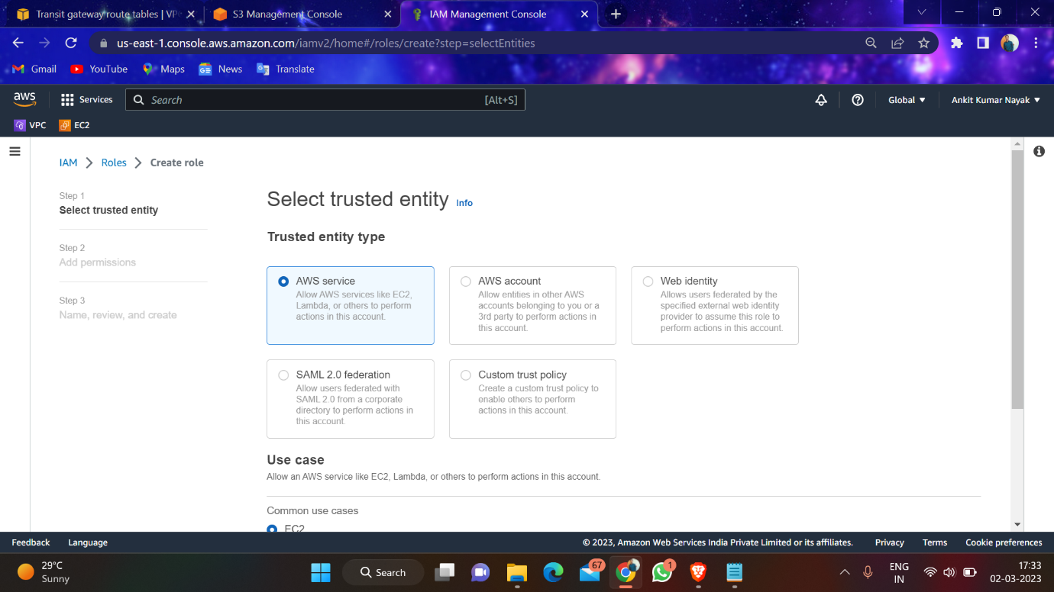

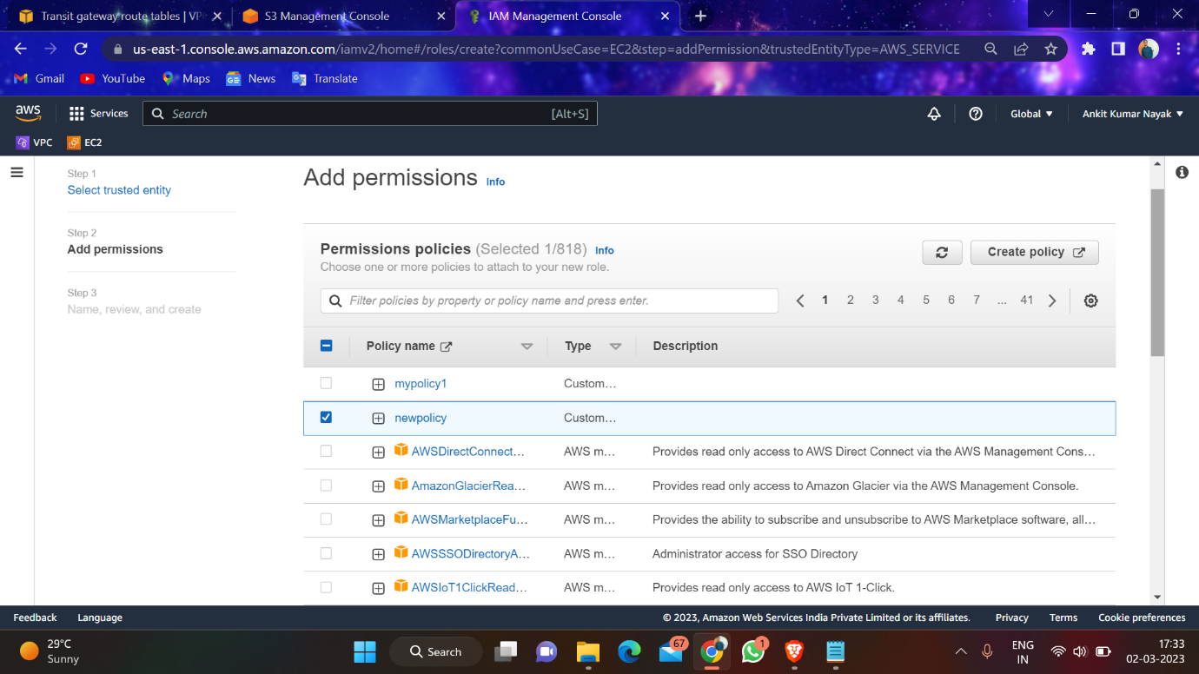

For 2nd bucket



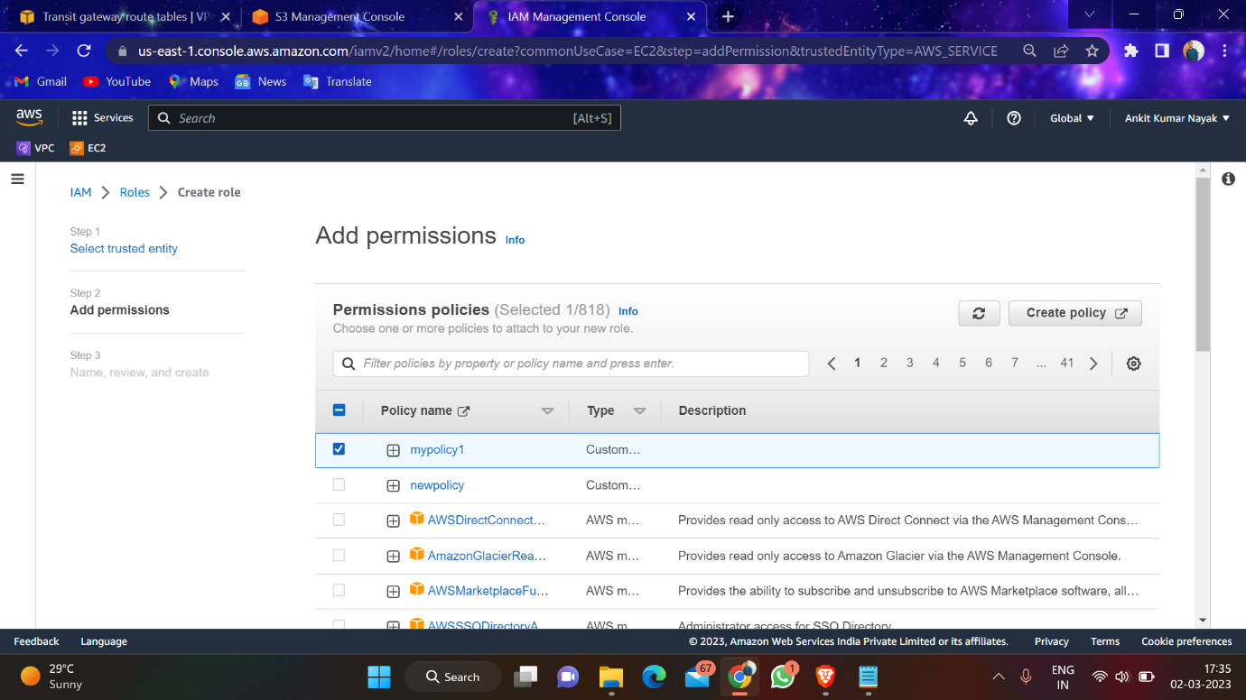

12- When u try to logging into 1st machine and try to read the bucket we are able to but if we want to copy any file into it it will show error

1. To list the item in buckets

Aws s3 ls s3://bucketname

2-To create a file

Touch file1

3-To copy the file into bucket

Aws s3 cp s3://bucketname/file1

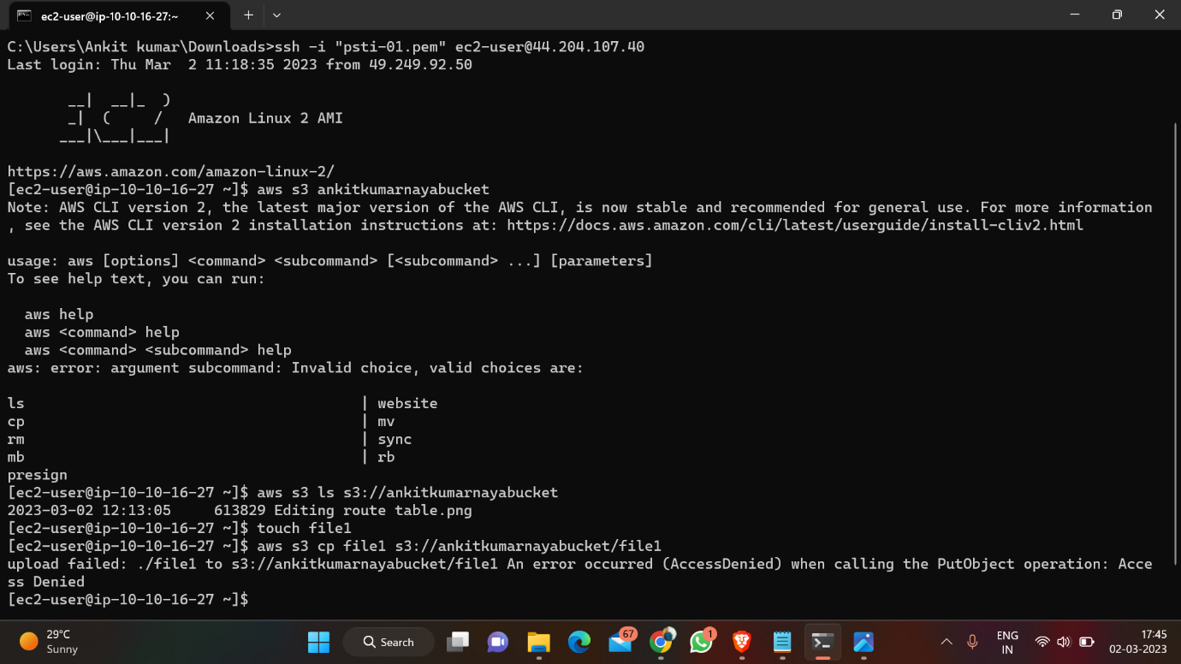

13- Goto your polices and edit polices

Resource🡪object, add your 2nd bucket name and give object as any.

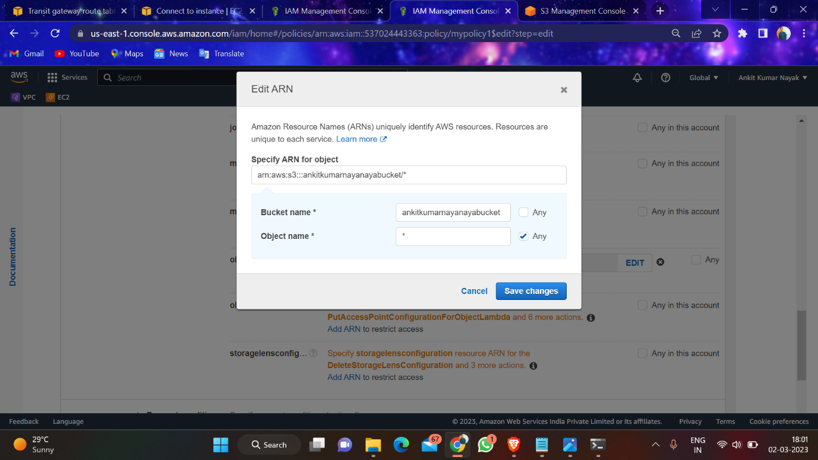

14- When u try to logging into 2nd machine and try to read the bucket we are able to and if we want to copy any file into it it will copy and list it

1. To list the item in buckets

Aws s3 ls s3://bucketname

2-To create a file

Touch file1

3-To copy the file into bucket

Aws s3 cp s3://bucketname/file1

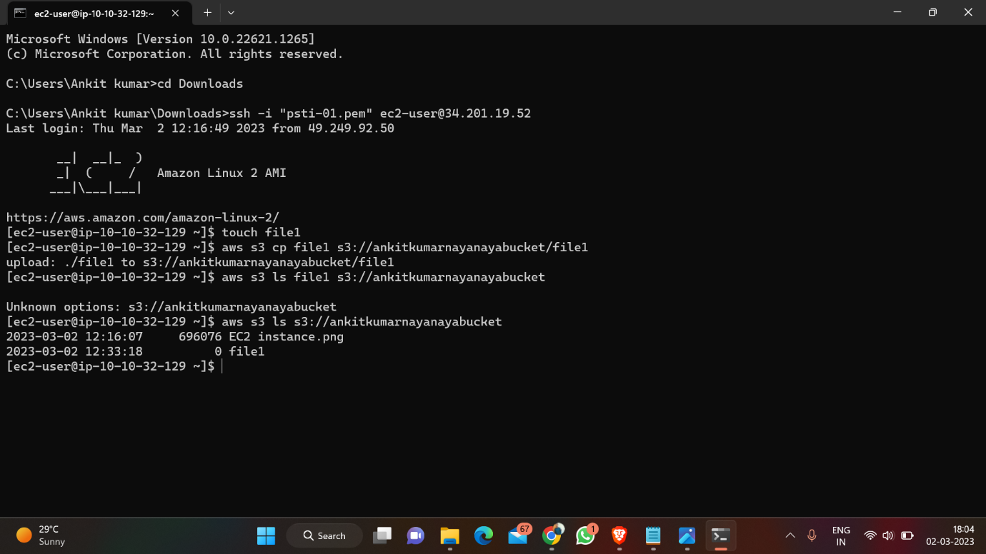

15- Now try to logging into 2nd machine and try to access the bucket of 3rd machine we will get error

